**INFOGRASS Technologies**  
***H&R Detailing***  
Discovery Phase - Understanding document

Version 0.2

Table of Contents

High-Level Design Document: Clarification Management Application 3

1.Executive Summary 3

2. System Overview 3

2.1 Purpose 3

2.2 Key Objectives 3

2.3 Authentication 3

3. Detailed Explanation 4

3.1 Cl No (Clarification Number) 4

3.2 Date 4

3.3 HRD Detailer Initials 5

3.4 Design Reference 5

3.5 Seq, Zone, Area 6

3.6 Stage 6

3.7 H&R SK# (Sketch Number) 7

3.8 Question 7

3.9 H&R RFI# (Request for Information Number) 7

3.10 Date Sent 8

3.11 Resp By (Responded By) 8

3.12 Response 9

3.13 Status 9

3.14 Response Date 10

3.15 Work Done By 10

3.16 Additional Notes 10

4. User Roles and Permissions 11

4.1 Branch User (Admin) 11

4.2 Headquarters User 11

5. Filtering and Search Capabilities 12

5.1 Advanced Filtering Options 12

High-Level Database Design 12

1. Table Definitions 12

High Level Design Document: UI design 15

Conclusion 23

# High-Level Design Document: Clarification Management Application

## 1.Executive Summary

The Clarification Management Application is an internal tool designed to streamline communication between branch offices and headquarters, providing a robust platform for managing project clarification logs with advanced filtering and tracking capabilities.

## 2. System Overview

### 2.1 Purpose

* Replace existing Excel-based tracking system

* Provide a centralized, digital platform for project clarification questions

* Enable efficient communication and documentation between branch and headquarters

### 2.2 Key Objectives

* Comprehensive question tracking
* Advanced filtering and search capabilities
* Role-based access control

* Audit trail and historical tracking

### 2.3 ****Authentication****

* Sign-in process requiring email and password (stored securely in the database using encryption).
* Multi-factor authentication (MFA) for added security, combined with JSON Web Tokens (JWT) for session management and secure access control.
* Role-based access control to manage privileges within the system.

## 3. Detailed Explanation

### 3.1 Cl No (Clarification Number)

**Description**: Unique sequential identifier for each clarification question

**Purpose**:

* Provides a systematic way to track and reference individual clarification requests

* Ensures no duplicate questions are created

* Allows for easy sorting and referencing

**Validation Rules**:

* Mandatory field

* Unique across the system

* Generated automatically upon question creation

### 3.2 Date

**Description**: Date when the clarification question is created

**Purpose**:

* Tracks the timeline of project communication

* Helps in understanding the chronology of questions

* Used for aging analysis and response time tracking

**Validation Rules**:

* Cannot be a future date

* Defaults to current system date

* Allows filtering of questions by date ranges

### 

### 3.3 HRD Detailer Initials

**Description**: Three-letter identifier assigned to a specific project or detailer

**Purpose**:

* Quickly identifies the project or responsible personnel

* Enables tracking of questions by specific teams or individuals

* Provides a shorthand reference for project identification

**Validation Rules**:

* Must be exactly 3 characters

* Case-sensitive

* Predefined list of valid initials in the system

### 3.4 Design Reference

**Description**: Categorization of the clarification question

**Purpose**:

* Classifies questions into specific project domains

* Helps in routing questions to appropriate departments

* Enables focused filtering and reporting

**Potential Categories**:

* General

* Structural

* Architectural

* Mechanical

* Electrical

* Plumbing

* Other

### 3.5 Seq, Zone, Area

**Description**: Specific project location or sequence identifier

**Purpose**:

* Precisely locates the context of the clarification question

* Allows granular filtering of project-specific queries

* Helps in understanding the spatial context of the question

**Example Formats**:

* Sequence: S01, S02

* Zone: GU560, NE200

* Area: Main Building, West Wing

### 3.6 Stage

**Description**: Current project phase for the clarification question

**Purpose**:

* Tracks the project lifecycle stage

* Helps in understanding the context of the question

* Enables stage-specific reporting and analysis

**Potential Stages**:

* Design Review

* Fabrication

* Approval

* Construction

* Final Review

* Completed

### 3.7 H&R SK# (Sketch Number)

**Description**: Unique identifier for associated sketch or drawing

**Purpose**:

* Links clarification questions to specific technical documents

* Provides context and reference for the question

* Allows tracking of questions related to specific sketches

**Validation Rules**:

* Optional field

* Must reference existing sketches in the system

### 3.8 Question

**Description**: Detailed text of the clarification request

**Purpose**:

* Captures the specific query or point of confusion

* Provides complete context for headquarters review

* Serves as a historical record of communication

**Validation Rules**:

* Mandatory field

* Maximum length of 255 characters

* Supports rich text formatting

### 3.9 H&R RFI# (Request for Information Number)

**Description**: Tracking number for escalated or complex questions

**Purpose**:

* Manages questions requiring additional investigation

* Provides a formal mechanism for complex clarifications

* Tracks the resolution process for challenging queries

**Validation Rules**:

* Optional field

* Unique identifier

* Follows organization's RFI numbering convention

### 3.10 Date Sent

**Description**: Date when RFI or clarification is formally sent

**Purpose**:

* Tracks the timing of communication

* Measures response times

* Provides audit trail for project communications

**Validation Rules**:

* Cannot be in the future

* Must be after the original question date

### 3.11 Resp By (Responded By)

**Description**: Name or identifier of the person responding

**Purpose**:

* Accountability for responses

* Tracking individual performance

* Understanding communication patterns

**Validation Rules**:

* Must be a valid user in the system

* Supports full names or user identifiers

### 3.12 Response

**Description**: Detailed text of the clarification response

**Purpose**:

* Provides clear, documented answers to questions

* Creates a knowledge base for future reference

* Ensures transparent communication

**Validation Rules**:

* Mandatory for closed questions

* Maximum length of 255 characters

* Supports rich text formatting

### 3.13 Status

**Description**: Current state of the clarification question

**Purpose**:

* Tracks progress of communication

* Enables filtering of open and closed questions

* Provides quick visual status

**Possible Values**:

* Open

* Closed

### 3.14 Response Date

**Description**: Date when the response is provided

**Purpose**:

* Tracks response timelines

* Measures communication efficiency

* Provides historical context

**Validation Rules**:

* Cannot be before the original question date

* Defaults to current date when response is submitted

### 3.15 Work Done By

**Description**: Identifier of the person completing the work related to the question

**Purpose**:

* Tracks task completion

* Provides accountability

* Helps in performance tracking

**Validation Rules**:

* Must be a valid user in the system

* Supports full names or user identifiers

### 3.16 Additional Notes

**Description**: Supplementary information about the question or response

**Purpose**:

* Captures additional context

* Provides space for supplementary details

* Ensures comprehensive documentation

**Validation Rules**:

* Optional field

* No length restrictions

* Supports rich text formatting

## 4. User Roles and Permissions

### 4.1 Branch User (Admin)

* Full CRUD (Create, Read, Update, Delete) permissions

* Can create new clarification questions

* Can edit existing questions

* Full access to all application features

### 4.2 Headquarters User

* Read-only access to most features

* Can respond to questions

* Can create RFI (Request for Information)

* Cannot modify existing questions

## 5. Filtering and Search Capabilities

### 5.1 Advanced Filtering Options

**Status Filtering**

Open questions

Closed questions

Mixed status

**Date Range Filtering**

Filter by creation date

Filter by response date

Custom date range selection

**Detailed Search Filters**

Search by Clarification Number

Search by HRD Detailer Initials

Filter by Sequence/Zone/Area

Search by Sketch Number (e.g., SK01)

Filter by Respondent

Search by RFI Number

# 

# ****High-Level Database Design****

## ****1. Table Definitions****

**Table: CL_Item**

|  |  |  |  |
| --- | --- | --- | --- |
| Column Name | Data Type | Constraints | Description |
| CL_No | INT (Primary Key) | Auto-increment | Unique identifier for each CL item. |
| Date | DATE | NOT NULL | The date the CL item was created. |
| HRD_Initials | VARCHAR(10) | NOT NULL | Initials of the HRD detailer. |
| Design_Reference_ID | INT | Foreign Key | Links to the Design_Reference table. |
| Seq_Zone_Area | VARCHAR(50) | NULLABLE | Zone or area sequence. |
| Stage_ID | INT | Foreign Key | Links to the Stage table. |
| Question | TEXT | NOT NULL | The query or issue raised. |

**Table: Stage**

|  |  |  |  |
| --- | --- | --- | --- |
| Column Name | Data Type | Constraints | Description |
| Stage_ID | INT (Primary Key) | Auto-increment | Unique identifier for each stage. |
| Stage_Name | VARCHAR(50) | NOT NULL | Name of the stage (e.g., General, Approval). |

**Table: Status**

|  |  |  |  |
| --- | --- | --- | --- |
| Column Name | Data Type | Constraints | Description |
| Status_ID | INT (Primary Key) | Auto-increment | Unique identifier for status. |
| Status_Name | VARCHAR(10) | NOT NULL | Status of the item (e.g., Open, Closed). |

**Table: Response**

|  |  |  |  |
| --- | --- | --- | --- |
| Column Name | Data Type | Constraints | Description |
| Response_ID | INT (Primary Key) | Auto-increment | Unique identifier for each response. |
| CL_No | INT | Foreign Key | Links to the CL_Item table. |
| Response_Text | TEXT | NOT NULL | The response provided for the CL item. |
| Response_Date | DATE | NOT NULL | Date of the response. |

**Table: Communication_Log**

|  |  |  |  |
| --- | --- | --- | --- |
| Column Name | Data Type | Constraints | Description |
| Log_ID | INT (Primary Key) | Auto-increment | Unique identifier for each communication log. |
| CL_No | INT | Foreign Key | Links to the CL_Item table. |
| Communication | TEXT | NOT NULL | Details of communication (e.g., email logs). |
| Timestamp | TIMESTAMP | DEFAULT CURRENT_TIMESTAMP | Date and time of the communication. |

**Table: Design_Reference**

|  |  |  |  |
| --- | --- | --- | --- |
| Column Name | Data Type | Constraints | Description |
| Design_Reference_ID | INT (Primary Key) | Auto-increment | Unique identifier for design references. |
| Reference_Name | VARCHAR(50) | NOT NULL | Name or code of the design reference. |
| Details | TEXT | NULLABLE | Additional details about the reference. |

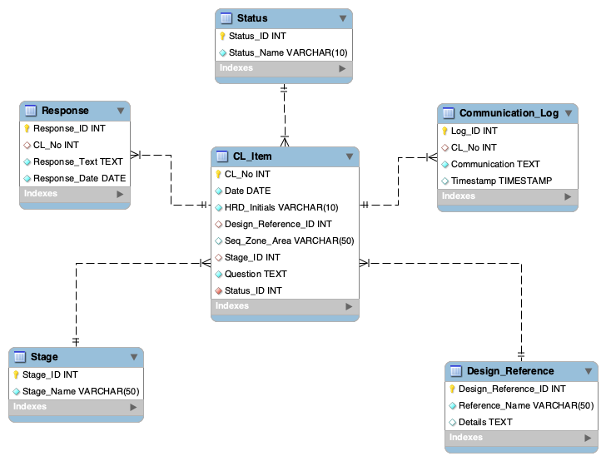2**. ER Diagram:**

# 

# High Level Design Document: UI design

Branch (Admin)

Log in:

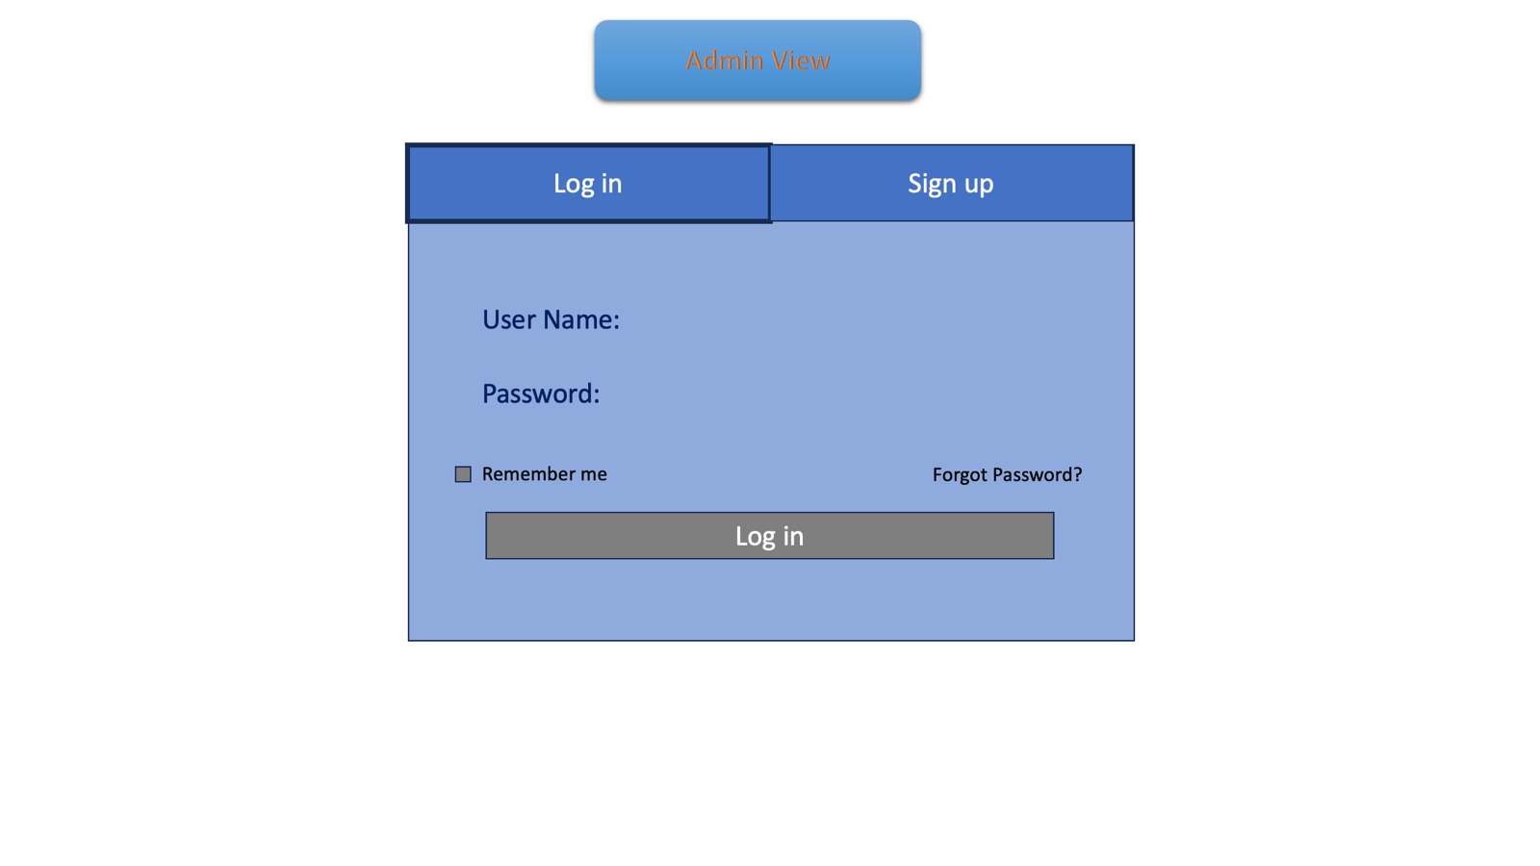

Sign up:

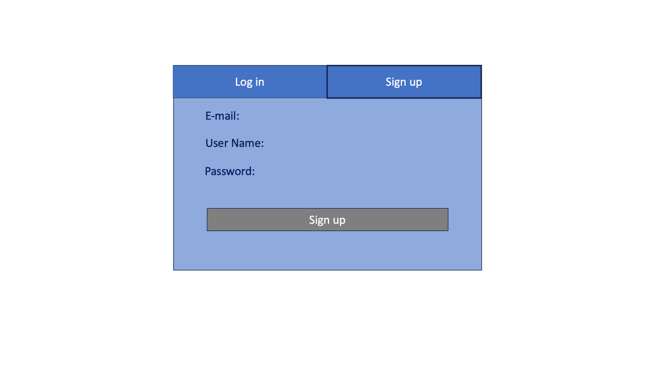

Main View:

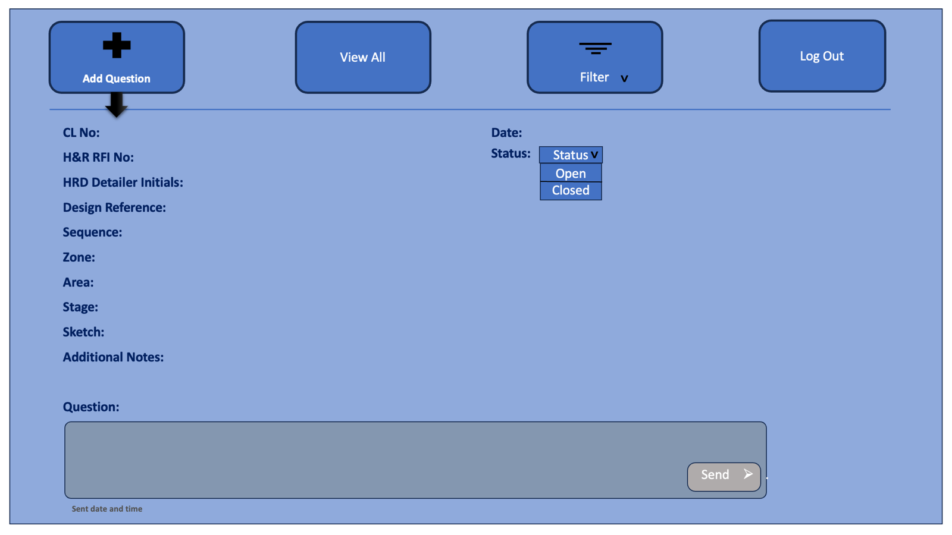

View All: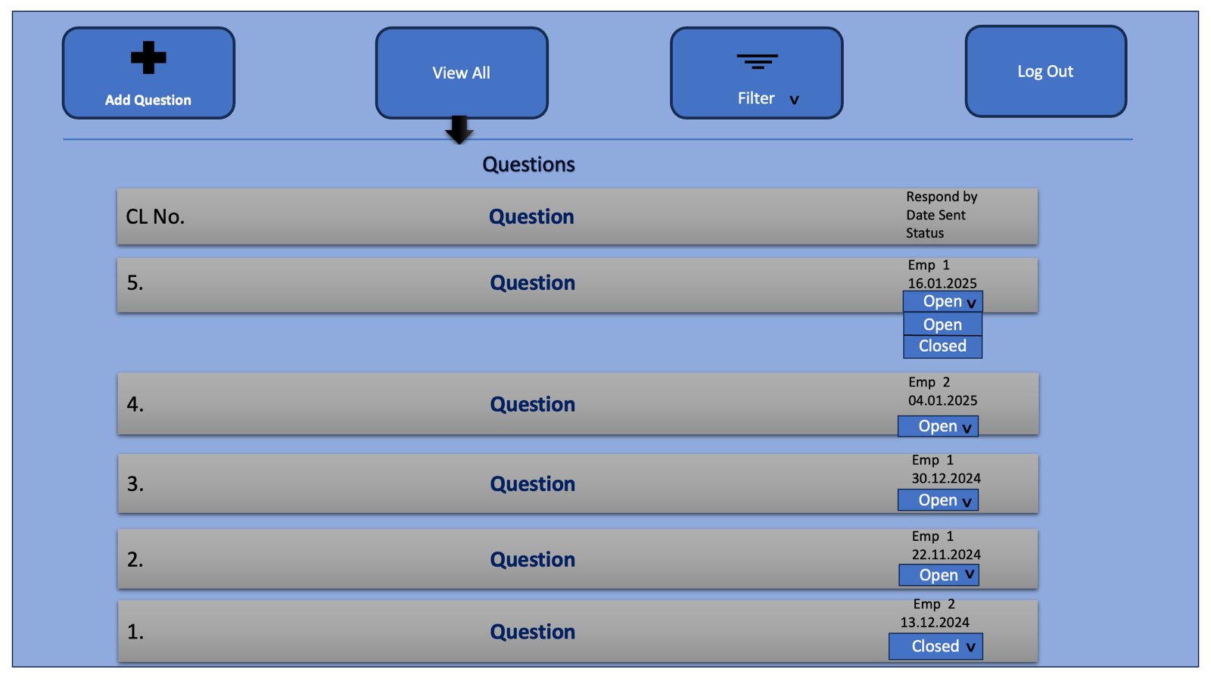

Question View:

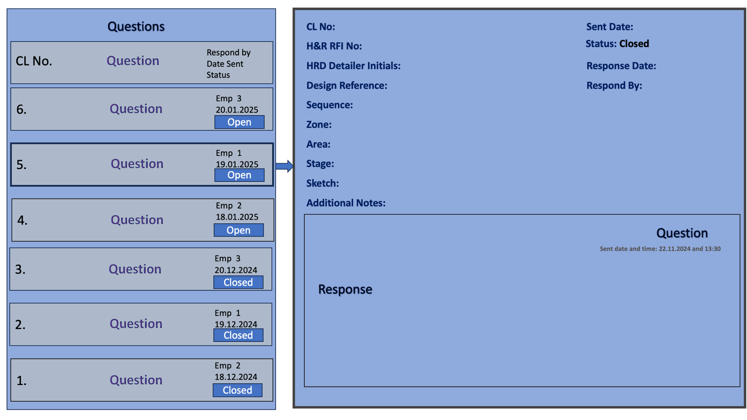

Filter View: 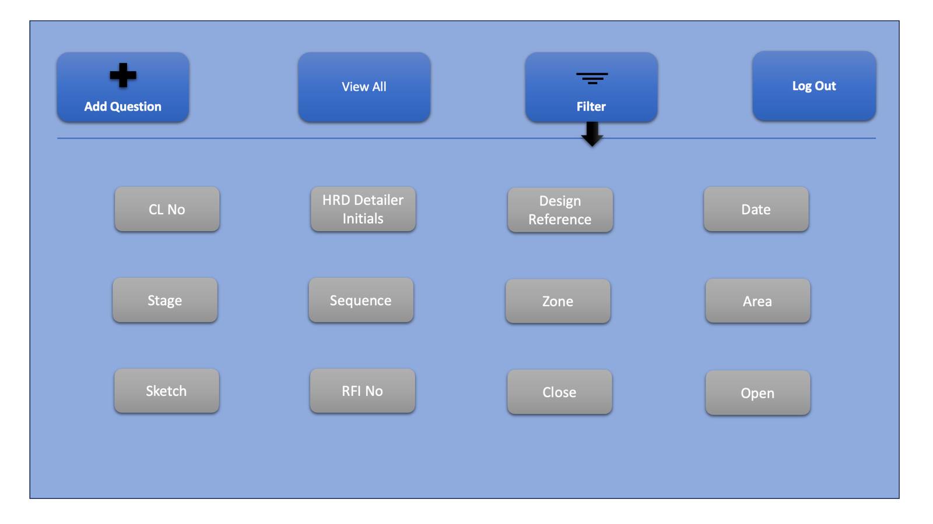

Filter Based on HRD Detailer Initials:

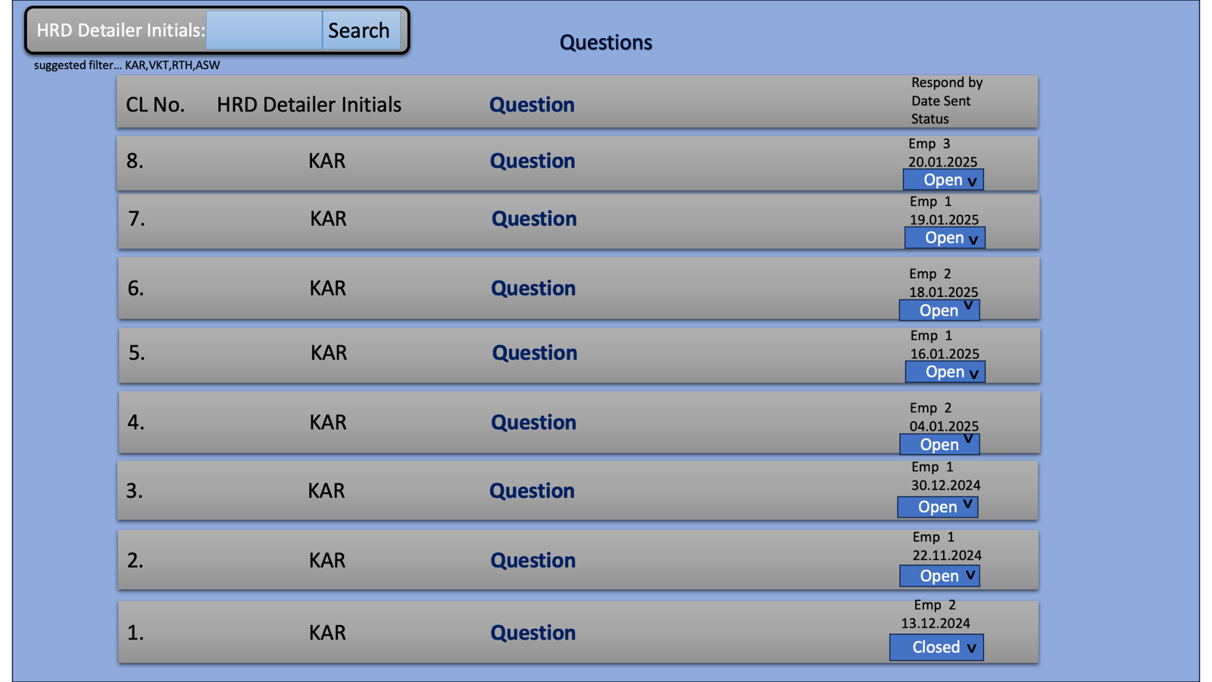

Filter Based on Design Reference: 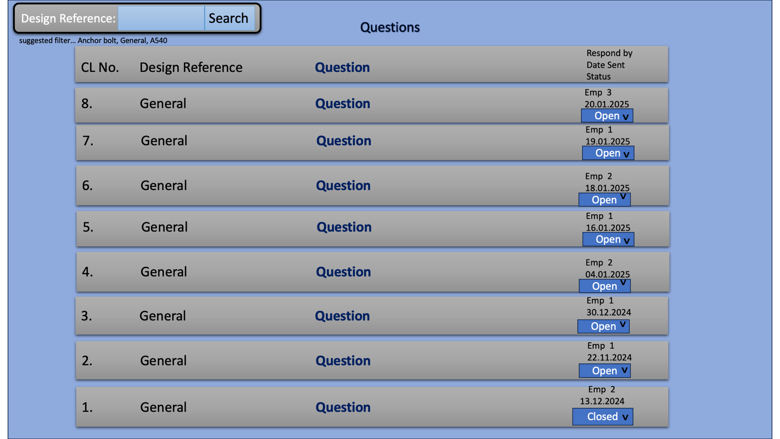

Filter Based on Date Range: 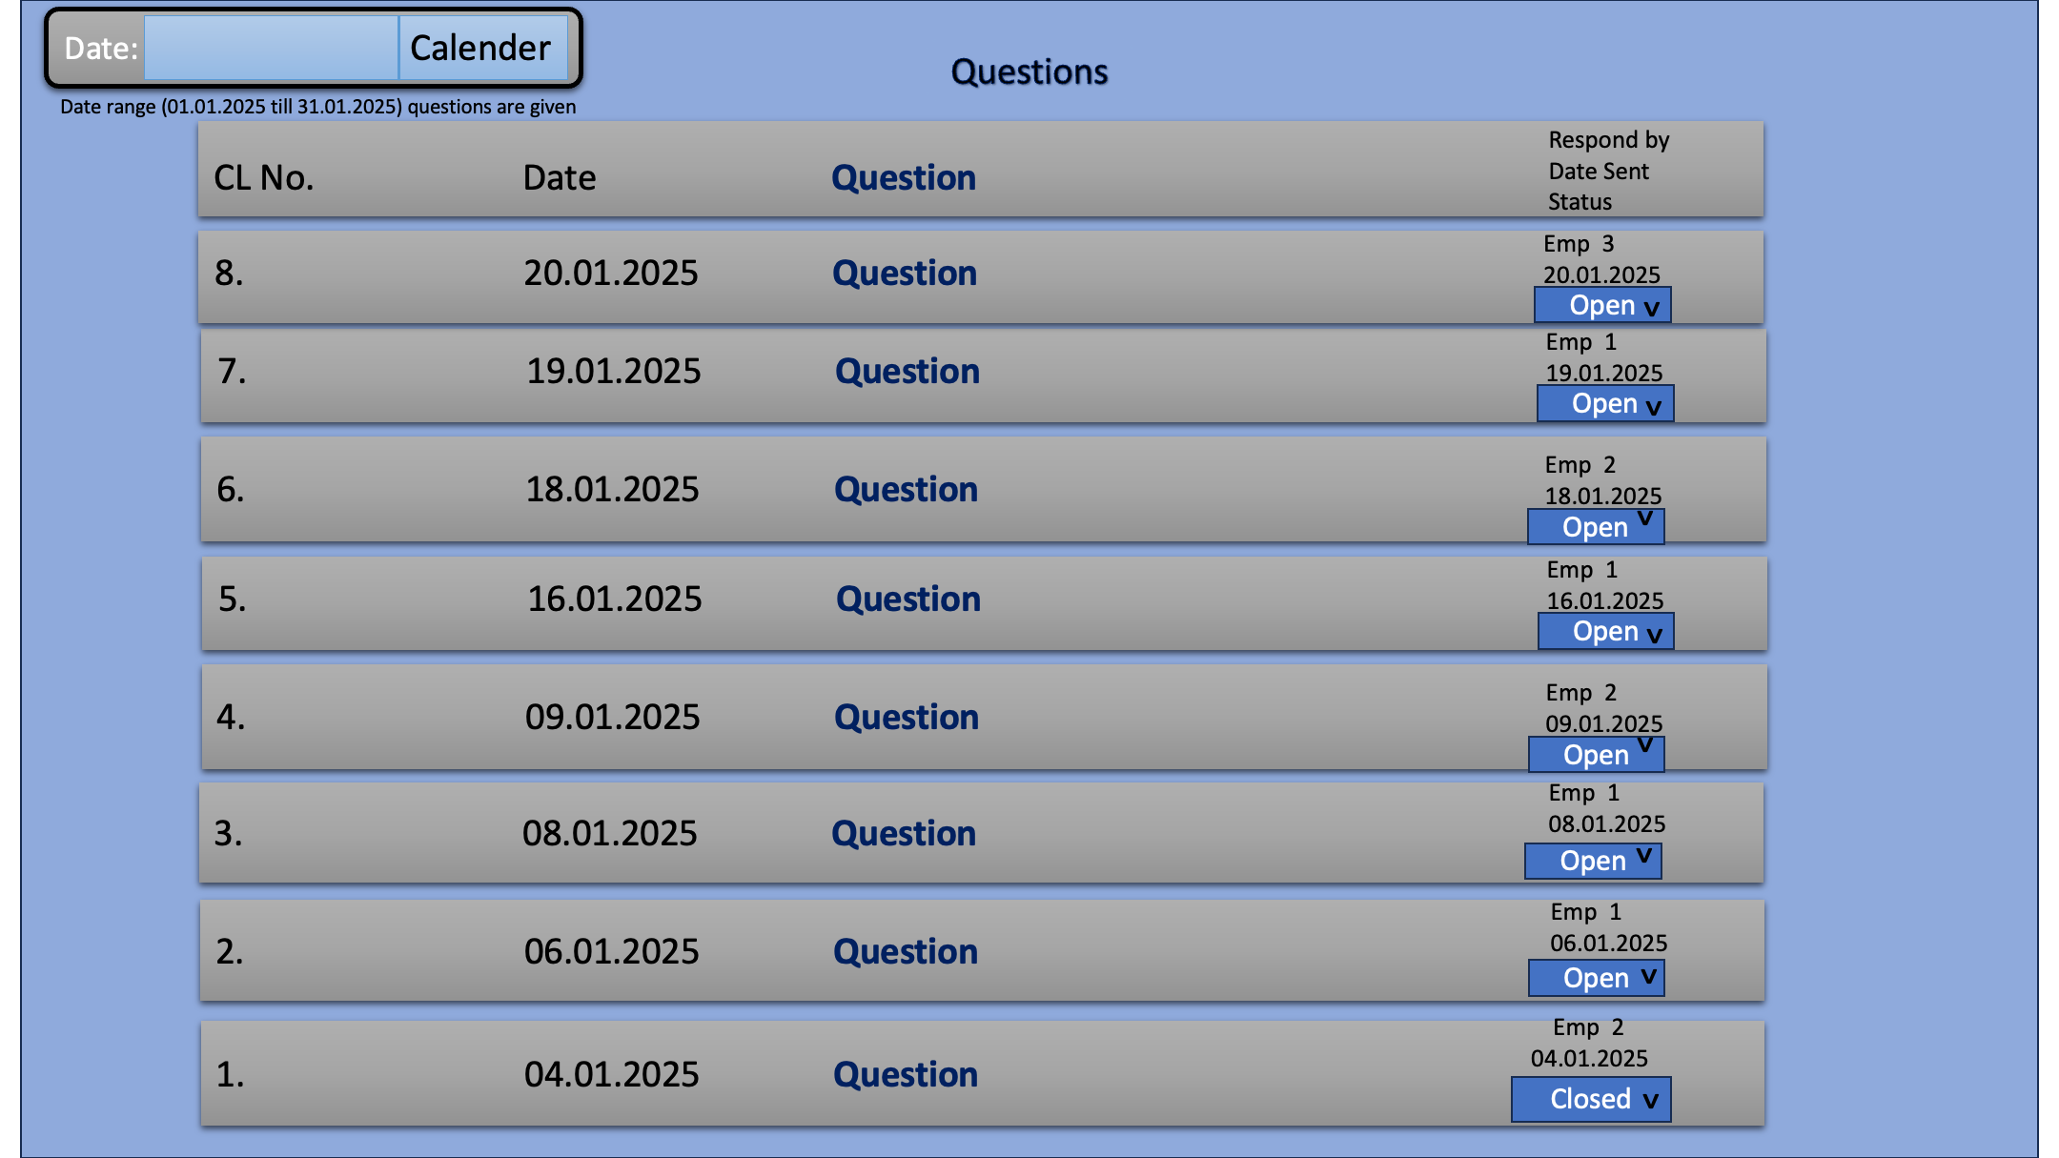

Filter Based on Stage: 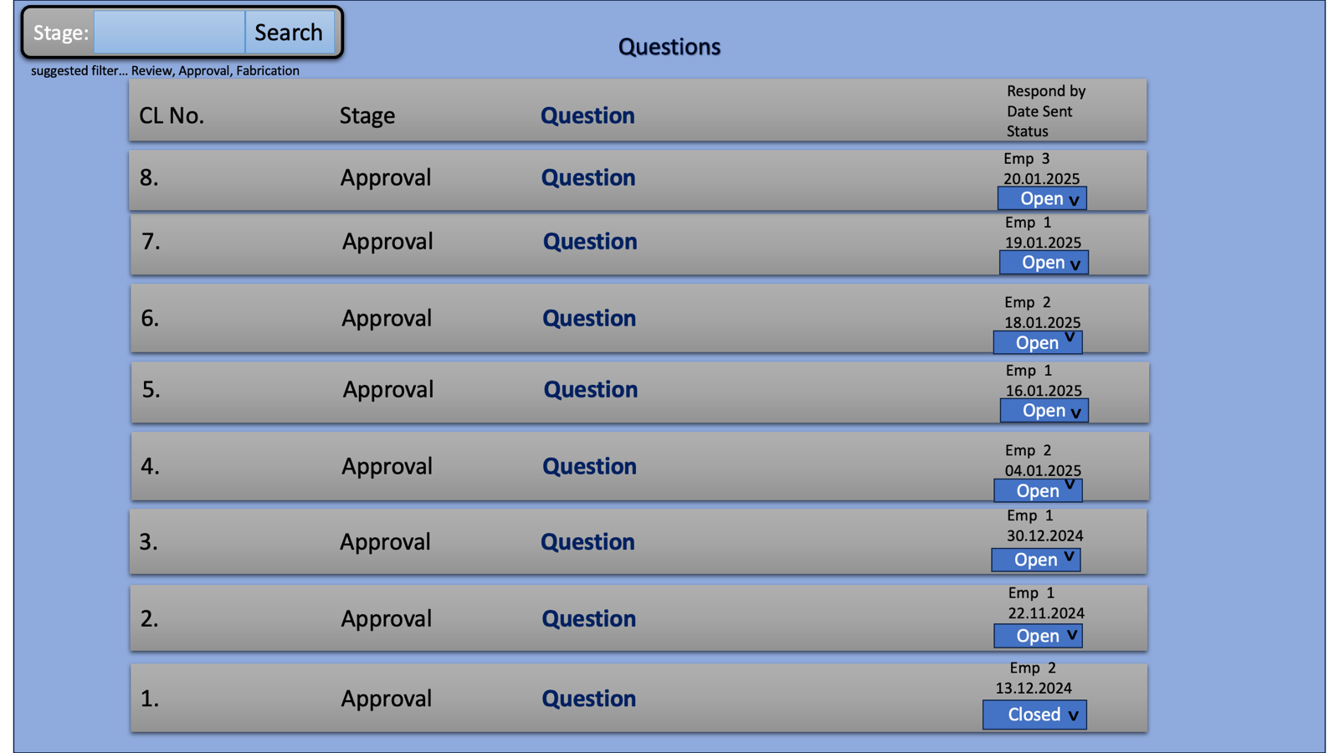

Filter Based on Sketch Number:

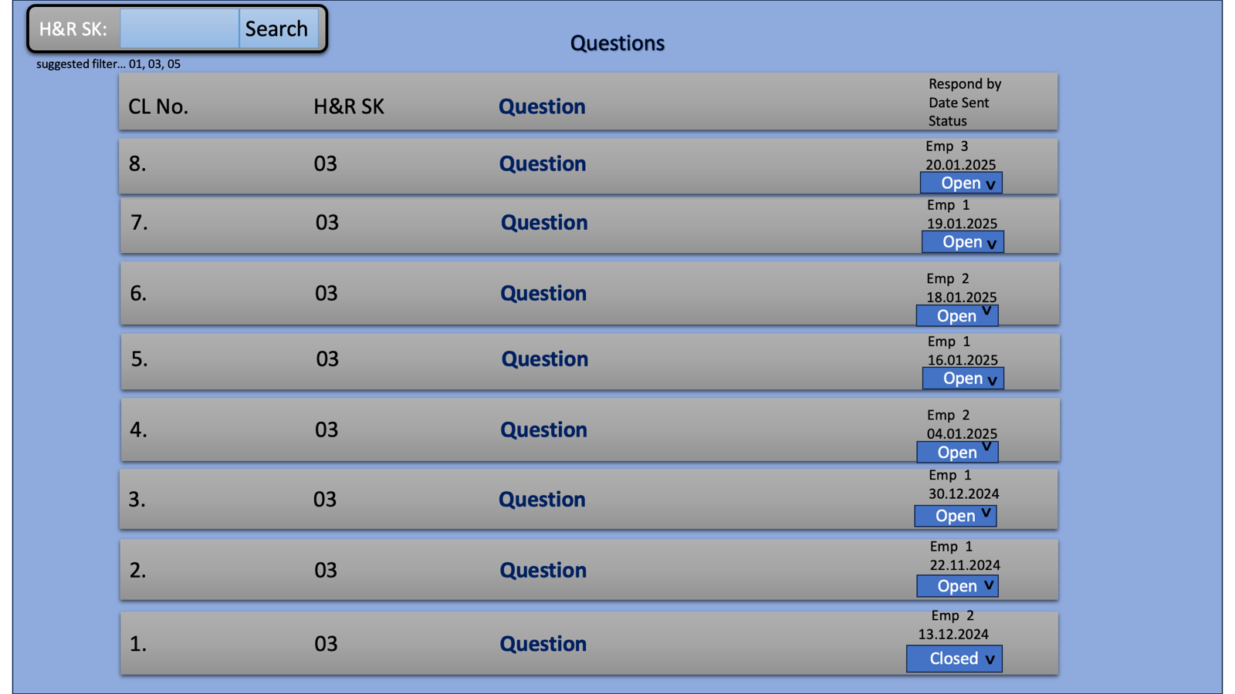

Headquarters (client)

Log in: 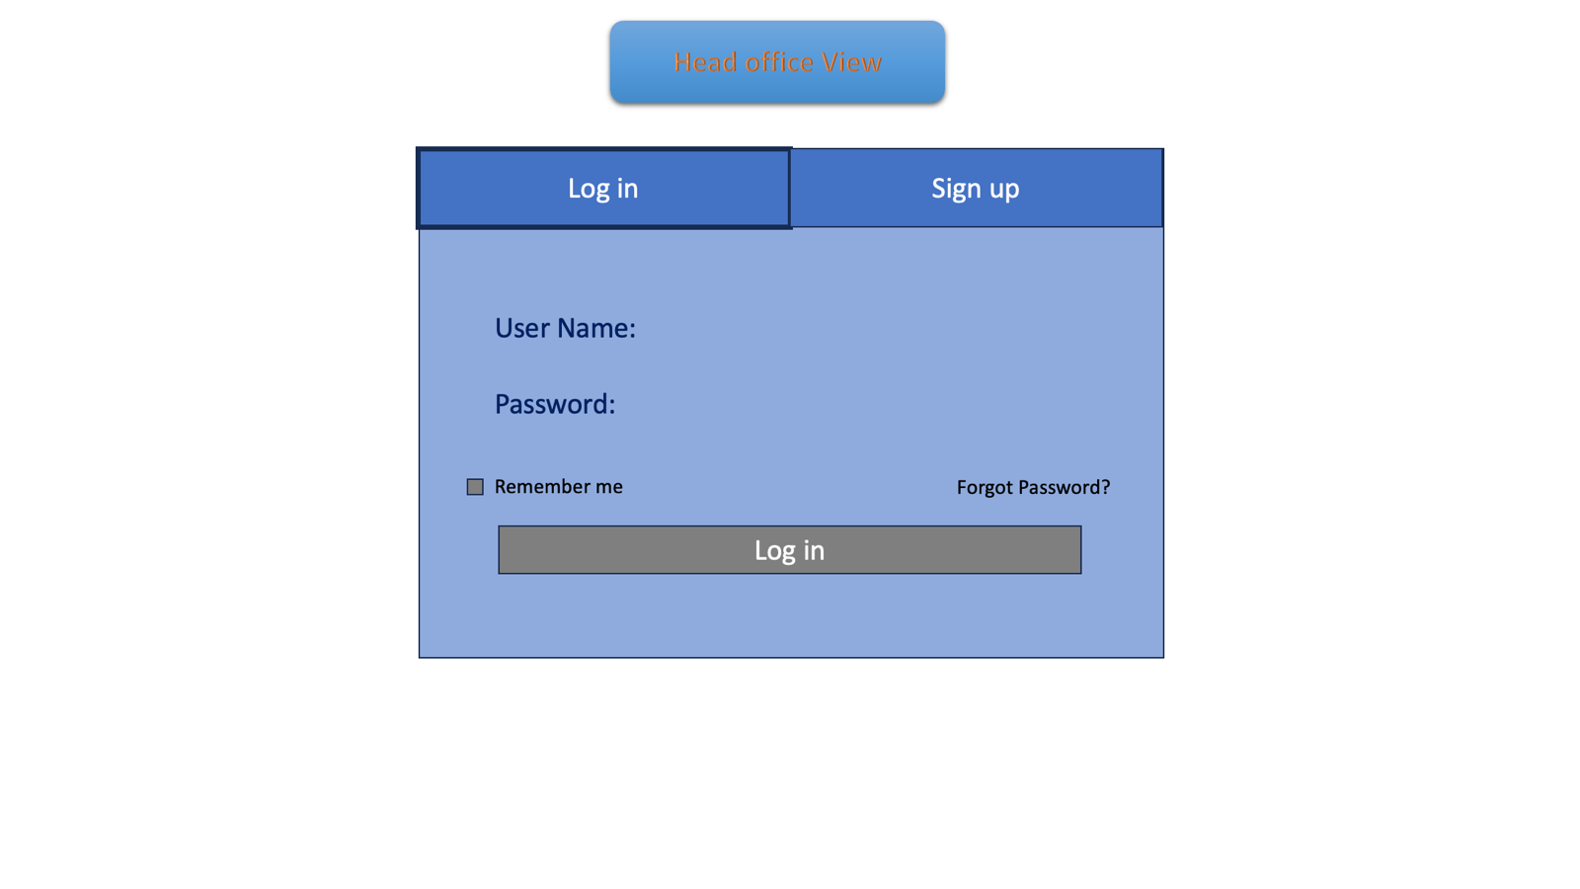

Sign up:



Main View: 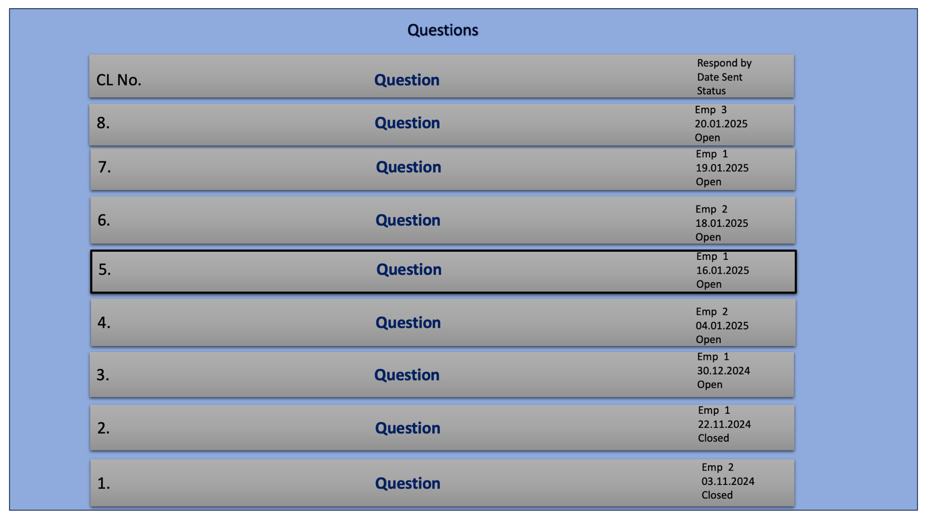

Providing response: 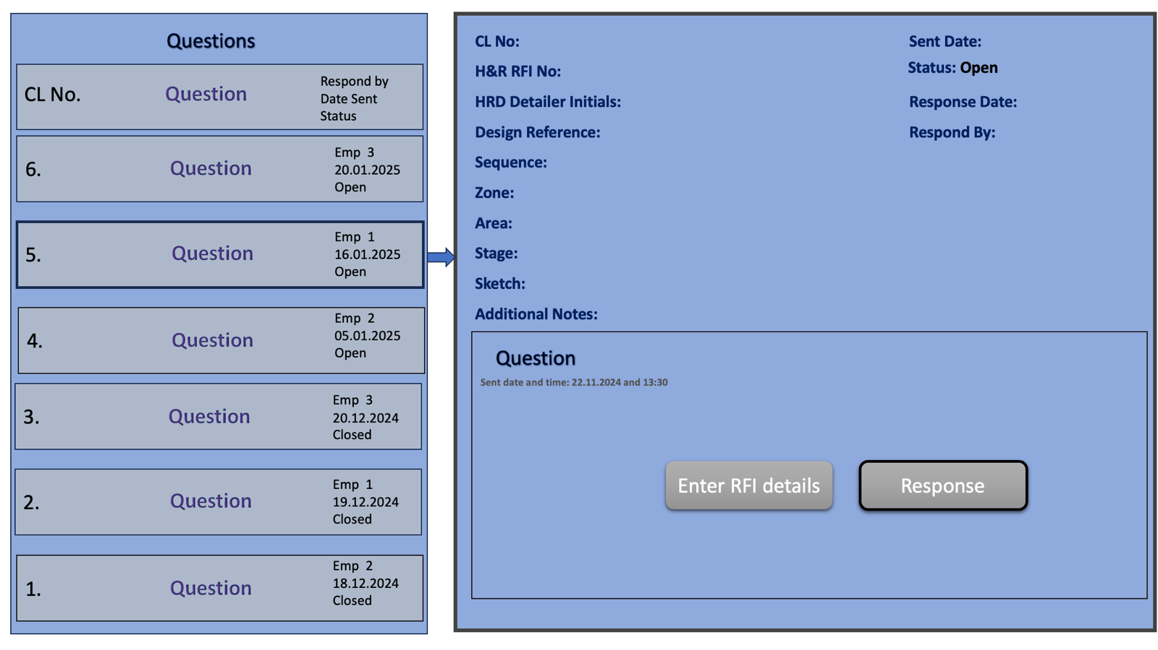

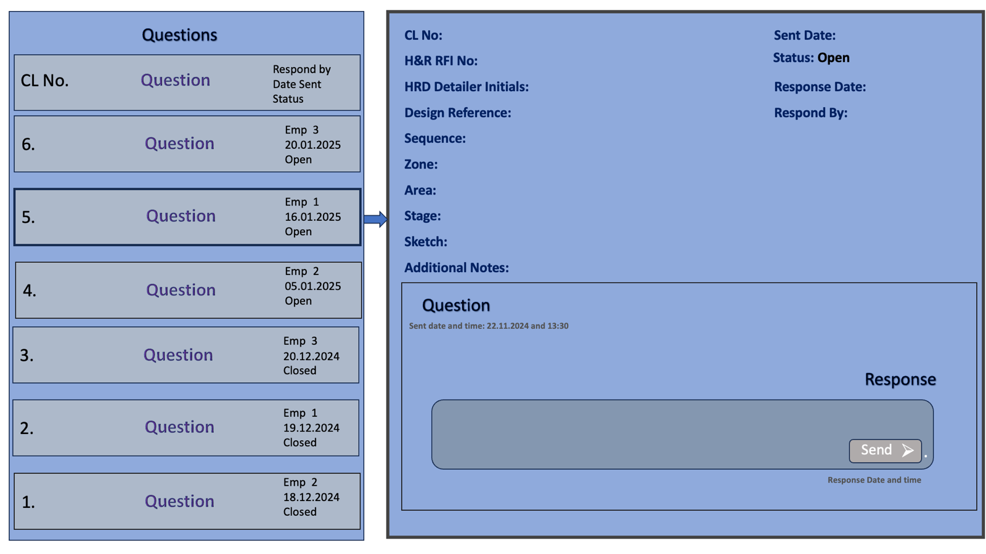

Transferring to RFI: 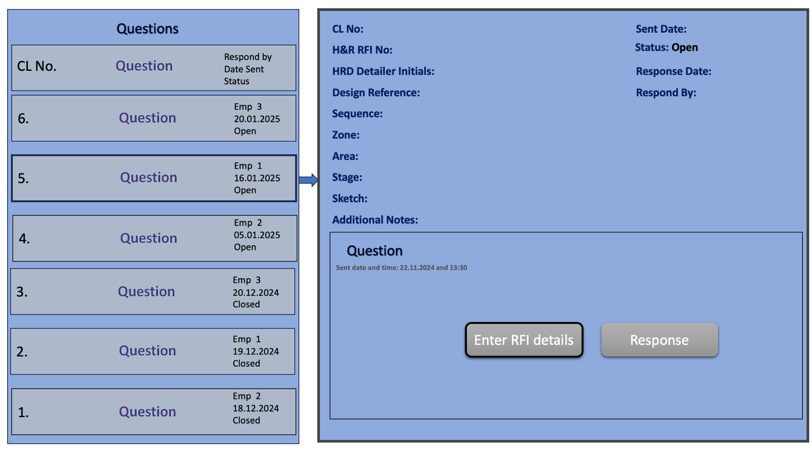

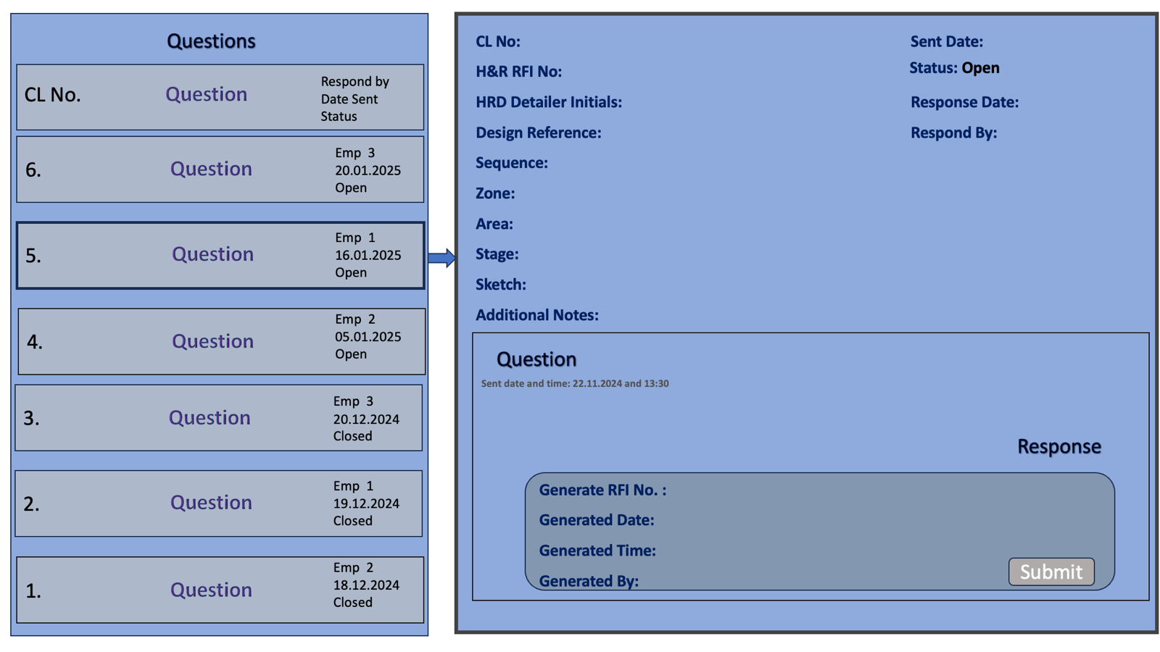

## Conclusion

This document serves as the Basic Understanding Document based on the provided inputs high level design document are subject to refinement or enhancement based on your feedback. All changes are managed systematically using version control.